PRICE DISCRIMINATION

“Price discrimination is the practice of charging different prices for the same product when the difference is not justified by differences in production/supply cost.”

Why?  The objective of the firm is to increase the profits through reducing the consumer surplus.  Consumer surplus is a measure of consumer welfare gained by consumers being able to purchase a good or service in the market at a price lower that the maximum that they would be prepared to pay. | 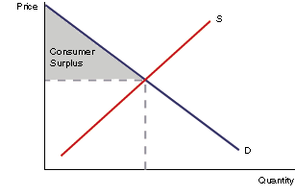
Necessary Conditions for Price Discrimination
There are some necessary conditions for price discrimination to operate successfully;

- The firm must be able to set the price. This requires an imperfect market with high barriers to entry, (e.g. a monopoly or oligopoly).  - The markets must be separate. There must be no opportunity for consumers to resell the goods. This is why airline tickets are non-transferrable.  - The elasticity of demand must be different between the markets. On trains, childeren travel for less ~ their elasticity is different to adults. | 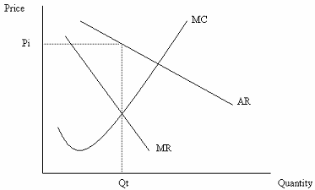

Note: In some countries it is illegal to sell competing buyers different prices for the same commodity. However, where there are demonstrably different costs associated with different buyers, (which may arise from a seller’s attempts to meet a competitor’s prices), price differentiation is generally legal.
Strategies
First-degree Price Discrimination ~ charge a different price for each unit according to each consumers demand function. No Consumer Surplus or Rent. But producer would need to know the demand functions for everyone (consumers unwilling to disclose) ∴very difficult to do. However, the emergence of e-commerce esp. B2C can be adopted to provide info on individuals (nb Amazon charge more for return business ?) resulting in tailored or customised offers.
Second-degree Price Discrimination ~ charge a uniform price per unit for a specified block / quantity sold to each consumer. Extracts part but not all the Consumer Surplus. Happens where demand can be metered ie electricity / photocopier usage (cheaper prices for bulk). Set a different price for ‘bands’ on the demand curve.
Third-degree Price Discrimination ~ charge a different price in different segments of the market. Most common. Can be separated by:
- Geography; exporter can charge different price abroad nb car market !
- Time; off peak pricing ie for hotels & holidays at last minute
- Nature of Product; dental work cannot be transferred.
- Type of Demand; selling to wholesellers as opposed to public
By charging differential prices, the price discriminator allows company to increase total profits above that which exists in uniform pricing ie by soaking up the Surplus
Price discrimination may be used as a predatory pricing tactic. Prices would be set below cost for certain customers to harm competition at the supplier’s level.

To the extent that businesses find ways to price discriminate, they eliminate the triangle of welfare loss and approach the economically efficient amount of production. Thus, the mere existence of monopoly does not prove there is economic inefficiency.
Limitations of Price Discrimination
The use of third degree price discrimination may or may not be in the interest of the consumer;
- The higher profit may be reinvested to improve the quality of the product. If this occurs then the consumer would gain. However, if the higher profit was redirected to higher shareholder dividends then price differentiation would cause the consumer to loose out.
- With two prices the consumer in the lower priced market may gain by paying a lower price than previously. However, the consumer in the higher priced market may lose out as the price is higher than if the firm did not price discriminate.
Every seller would price discriminate if there were not two major obstacles standing in the way;
- The seller must be able to distinguish between those buyers who are willing to pay a high price from those who are not.
- There must be substantial difficulty for a low-price buyer to resell to those willing to buy at a high price.

Finally, it is important to consider the wider effects. British Motor manufacturers stiff us as compared to prices on the Continent. This has led to consumer resentment and investigation by the Competition Commission. Need to not only consider whether technically feasible but also the implications to image & threat of State Intervention

Examples useful for an exam answer.
The case of third degree price discrimination is where consumers are grouped into two or more independent markets and different prices. The markets may be separated by time, place or income. Examples include a child and adult fare on public transport, first and economy class on an airplane, different tariffs on mobile telephones, classified by time of day or the network being connected to.

